NET 731 Practical Week 1 Activity
Project Overview
This capstone project simulates the role of an Azure Administrator responsible for designing, deploying, securing, and monitoring a cloud infrastructure using Microsoft Azure. Students must implement Azure services while ensuring the total cost remains within the $100 Azure for Students credit.
- Business Requirements for CTU Training Solutions
CTU Training Solutions is a training provider that needs a reliable cloud infrastructure to host its learning systems and store student data.
Business Needs
The organization requires a cloud solution that can:
- Host an online training website
- Store student records and course materials
- Provide secure remote access for administrators
- Ensure high availability and scalability
- Monitor system performance
- Keep infrastructure low-cost within the $100 student credit
- Azure services required
- Azure Virtual Machines
- Entra ID (Formerly Azure AD)
- Azure Back up
- Azure Blob storage
- Azure Monitor
- Azure SQL Database
- Azure App Service

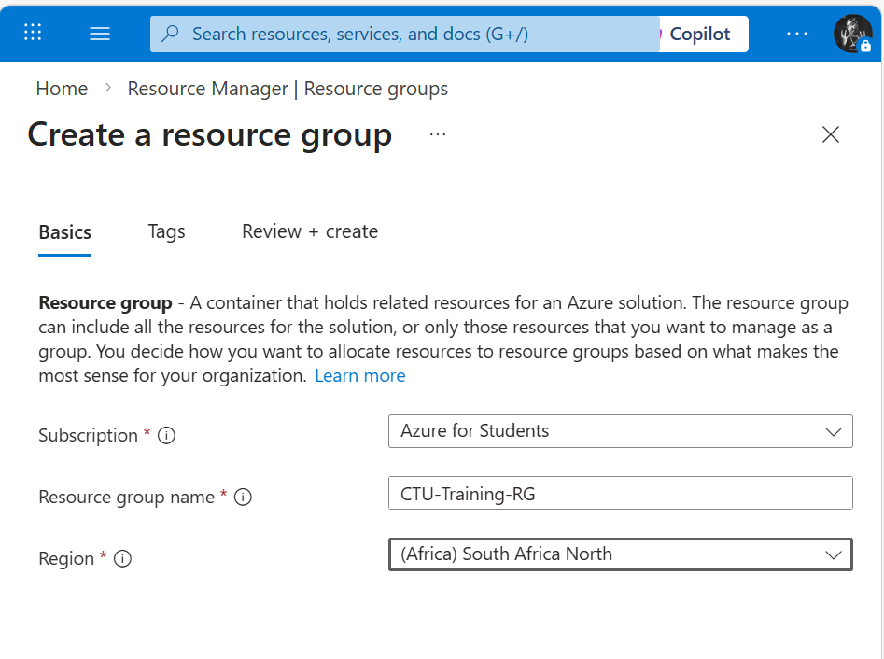
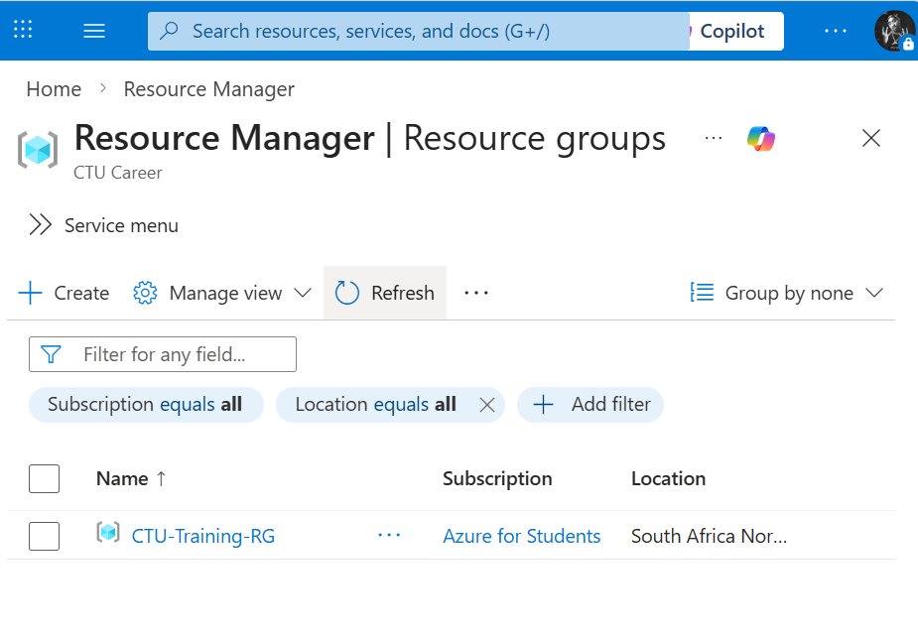
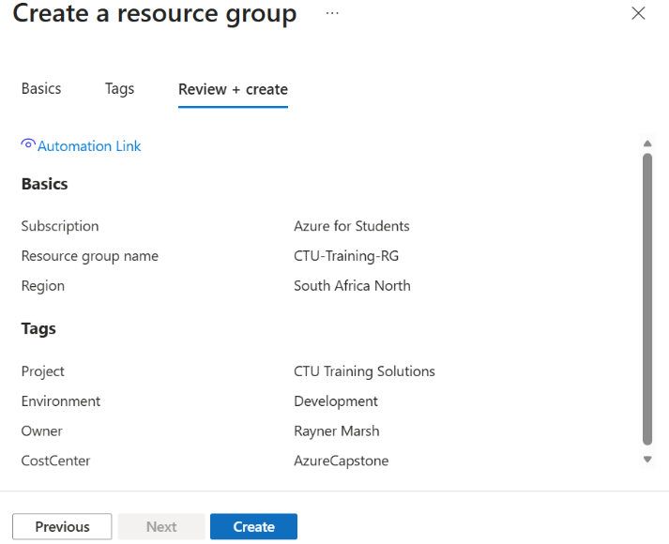
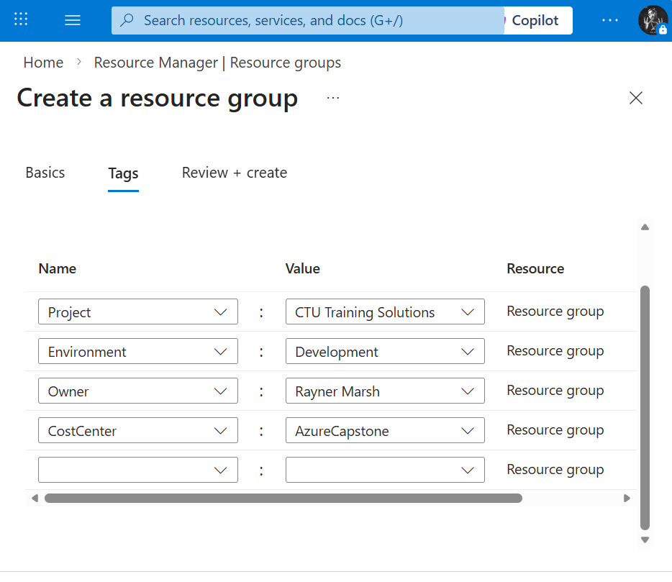
Week 1 Objectives
- Define business requirements for CTU Training Solutions
- Identify Azure services required
- Create Azure Resource Group in Azure for Students
- Document region, tags, and configuration

